Severe Weather Safety News Broadcast: Option 2
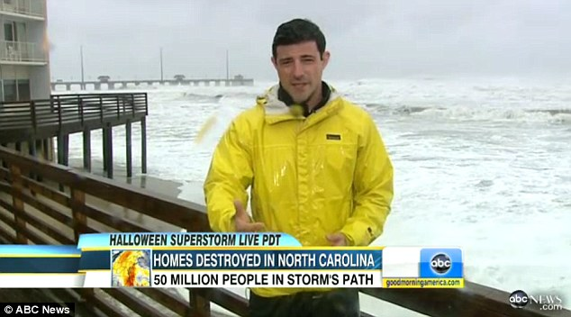
Use the information below to write a creative script and videotape yourself giving a news broadcast in which you report “live during a storm.” During the broadcast you will:
- State your name, location of broadcast, and name of news channel that employs you.
(Example: “This is David Lewandowski reporting live from PNC Park on Tiger TV.) 3 points

- Explain what type of severe weather is taking place and give facts about the event. (Choose a hurricane, tornado, blizzard, or lightning storm for your broadcast. Give “current” facts such as rainfall or snowfall amounts, wind speeds, power outages in the area, etc.) 3 points

- You will inform others whSat they should do to be safe during the severe weather. ( Give your listeners at least 4 safety tips from the list below.) 4 points

- Speak with enthusiasm! Speak clearly with a nice volume to the audience can hear you. Ask an adult to email your video to Mrs. Lewandowski at jlewandowski@northallegheny.org 3 points

- Add some special effects to make your broadcast seem authentic. Dress in warm clothes for a blizzard, raincoat for hurricane, add winds for hurricane/tornado or fake snow falling for blizzard. 2 points

Not necessary –but may be fun if you are handy with technology. You can use a green screen app from your iPad, iPod, or Smart Phone to video tape your presentation. This app allows you to give your report while standing in front of a green cloth or paper. You can then add an image from Google Images behind you to act as if you are reporting live from a certain place. We will do a similar project like this in the spring during ELA class. I will show you samples in class.

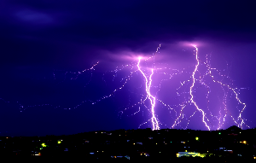
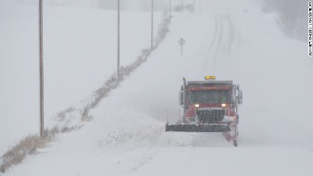
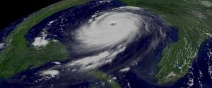
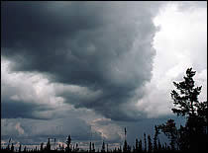

Tornado Hurricane Blizzard Lightning Storm
Blizzards: Strong winds, heavy snow, and low temperatures
- Prepare an emergency kit with a weather radio, batteries, cell phone and chargers, flashlight, generator, firewood, portable heaters, tools, 3 days of food, & water, first aid kit, medicines, and other valuable supplies.
- Gather warm clothes, coats, hats, and gloves for all family members. Dress in layers to stay warm.
- Avoid going outside.
- Gather rock salt, sand, shovels to keep walkways clear.
Tornado: Warning signs include: dark or green colored sky, low lying dark clouds, a loud roar like a freight train, and/or hail. Tornado develop quickly with little advanced warnings. They average tornado lasts 15 minutes.
- Do NOT stay in your car, bus, or mobile home. These items can be tossed about easily by a tornado. Get out of your vehicle and run to the nearest building.
- Move away from windows and glass doorways.
- Go to the basement or the lowest possible floor.
- Do not use elevators because the power may fail, leaving you trapped.
- Protect your head and make yourself as small a target as possible by crouching down.
- Crouch under a heavy object such as a table to protect your head or sit in the bathtub.
- If you are outside and not near shelter, stay away from tall trees. Do not hide under cars. Crouch down on the ground and protect your head.
Hurricane: Hurricanes form over warm oceans. Residents usually have a day(s) to prepare.

- Prepare an emergency kit with a weather radio, batteries, flashlight, generator, tools, 3 days of food & water, first aid kit, medicines, and other valuable supplies.
- Make a plan to communicate with family if there is no power or phone services.
- Know your surroundings and plan to evacuate to higher ground to avoid flooding and high winds if necessary. Fill up your gas tank.
- Cover glass windows and bring in outdoor furniture, garbage cans, and other items that may be destroyed by the high winds.
Lightning Storm: When it roars, go indoors! The safest place to be in a lightning storm is inside a large, fully enclosed building.

Indoors:
- Do not use telephones or appliances during storms because lightning can travel through these devices and shock the person using them. Note: Cell phones are permitted to use because they are not physically connected by wires.
- Unplug expensive electronic devices (tv, computers, etc.) to protect them from damage.
- Keep windows and doors locked. Stay away from glass windows and doors.
- Do not take a shower, bath, or do dishes during a lightning storm because water is a conductor and electricity can be carried through metal pipes to shock the person.
Outdoors:
- Avoid bodies of water, open areas, high ground, tall objects such as trees or light poles, and any metal objects such as fences, wires, metal sheds, golf clubs, bikes, or construction equipment.
- Avoid small shelters and pavilions in open areas that may attract lightning strikes.
- Do not find shelter under trees, or if necessary, choose the smallest trees in the area.
- When lightning is in the immediate area, crouch down with feet close together and head down to present the smallest possible attraction to strikes. Do not lie down, as this will increase the area for lightning to hit.
- Stay at least 15 feet away from other individuals in the area to prevent bolts from jumping from person to person.
- Cover your ears to minimize potential hearing damage from the accompanying thunderclap.
- If driving, pull off the road to avoid being blinded or startled by lightning strikes, and stay in your vehicle with the windows and doors closed.

SAFETY BROADCAST GRADING Due Date ________________________
________ /3 Name, Location, and News Channel
________/3 Three facts of severe weather taking place
________/4 Four safety tips
________/3 Speaks with enthusiasm, clarity, and appropriate volume
________/2 Special effects and appropriate dress or props
__________________/15 TOTAL GRADE

_______________ TOTAL Be creative and have fun!

